**ILLAWARRA WOODWORKERS GROUP INCORPORATED**

[**www.illawarrawoodworkers.org.au**](http://www.illawarrawoodworkers.org.au)



***Illawarra Woodworkers Group***

***June 2025 NEWSLETTER***

**New Committee 2025/26**

|  |  |
| --- | --- |
| President | Jason Hedley |
| Vice -president | Horacio Rodrigues |
| Secretary | Michael Cappelin |
| Treasurer | Darinka Radinovic |
| Assistant Treasurer | Julien Leveugle |
| Public Officer | William Perry |
| Coordinator (Organising) | Rick Funnell |
| Coordinator (Maintenance) | Pat Keefe |
| Coordinator (Workshop) | Jason Hedley |
| Club sales Coordinator | Darinka Radinovic |
| Librarian | Darinka Radinovic |
| Newsletter Editor | Virginie Schmelitschek / Julien Leveugle |
| Website Coordinator | Julien Leveugle |

***Hello Fellow Woodies***

The April Meeting was very quick. Pat told us that there is a “Turn Up” weekend in August on 8,9, and 10th at Lake Keepit, in Tamworth.

**AGM**: As you can see by the list above: we have a new Committee, chosen at AGM during the April Meeting, with some major changes. The first one is hat Pat Keefe has stepped down as Secretary, after 14 years! Thank you very much, Pat, for all those years of doing this job.

**MISSING**: There is a roll of chisels missing: Narex brand. Also an engineers square, plus a box of Allen keys, These were kept in the steel cabinet and are no long there. If YOU borrowed these, please return them.

Members, if ever you want to borrow something: **tell someone and write it on the board**.

At this meeting Horacio received the Annual Bill Boddy Trophy, for his work in our club – congratulations Horacio – well deserved.

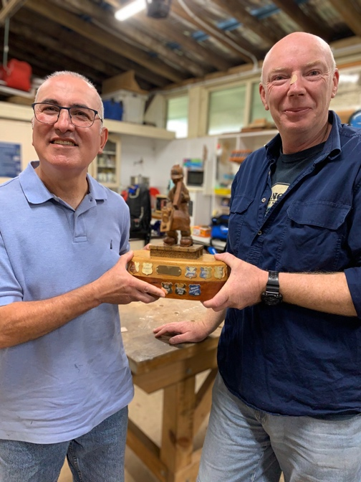

***Member news:***

Pat will hold a contest for us to make a Gotshall block. This is to test our skills. The block will be 175 x 175mm. We can start in September and finish it by November. Pat will get the materials for it. There will be a prize.

Rick would like a new emblem for the kids items, just like the one at the top of the newsletter.

***Workshop Safety***

***a monthly message from the Workshop Coordinator***

***(we cannot be reminded of this often enough!)***

**In early May a serious accident happened on the small (Harvey) bandsaw and one of our members had to be rushed to hospital as the tip of one of his fingers got in the way of the saw. Luckily after micro surgery he is on the mend.**

* **IMPORTANT**: Work shop safety must always be at the top of our list of priorities. Wear suitable clothes and enclosed shoes.
* Always ensure the dust **collector gates** are open when you use the equipment in the shed. ASK someone, if you are not sure what to do.
* Use the push sticks to keep your fingers away from blades.
* Know what thickness you can cut on the machine you are using.
* Get help with the correct procedure for the **sawdust bag**.
* Clean up a machine and the floor after use, if significant mess. **DO NOT ASSUME SOMEONE ELSE** will use it after you. Do it as you go.
* Put the hose in to the **vacuum cleaner** the right way! If it is not sucking up the mess, empty it!
* The drum sander **cannot** have painted or varnished timber going through it as it will clog up the sandpaper.
* The table saw is NOT a storage space
  + - NOT a work bench
    - Put NOTHING on the extension
    - The safety guard must be mounted AT ALL TIMES
* *Use eye, ear, head and feet protection too, no loose clothes, and, keep an eye on people around you.*
* *Sometimes it’s just the simple things we all forget, like if you have medium/long hair, tie it up if working close to moving machinery.*
* *NEVER be complacent –* ***blades bite!***

*(the last 3 dot points were copied from “Ingrained” the Knox newsletter)*

***LIBRARY***

Our club library is available to all members with copies of Australian Wood Worker, Fine Woodworking, etc. available to get some ideas on your next project. Just remember to sign out and back in anything that you need.

***Stalls and Events***

The Bulli Woodwork Show will be on in October or November.

On 30 May our club received a defibrillator through a grant from Bendigo Bank, and Wave FM was on hand to take our photo, with Mr. Hoy, the principal of Fairy Meadow demonstration School. A dust-free cupboard will be built for it, and we will receive instructions on how to use it – hopefully NEVER necessary!!

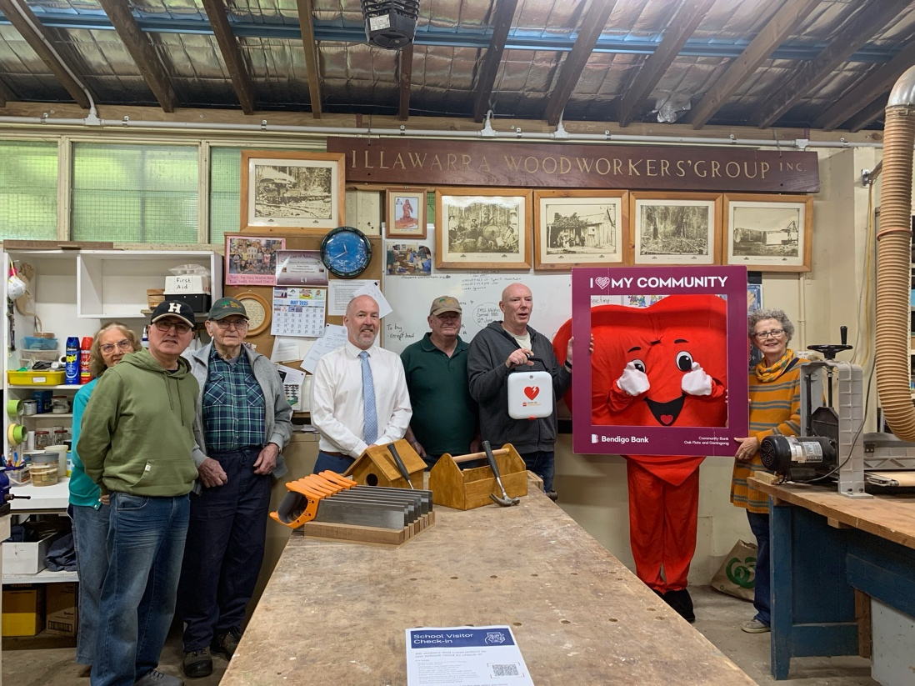

Our group was asked again to run a BBQ for the school at their Athletics Carnival on 12 June, which we did. Thank you to all those members who attended the day. Final income tally not available at time of writing.

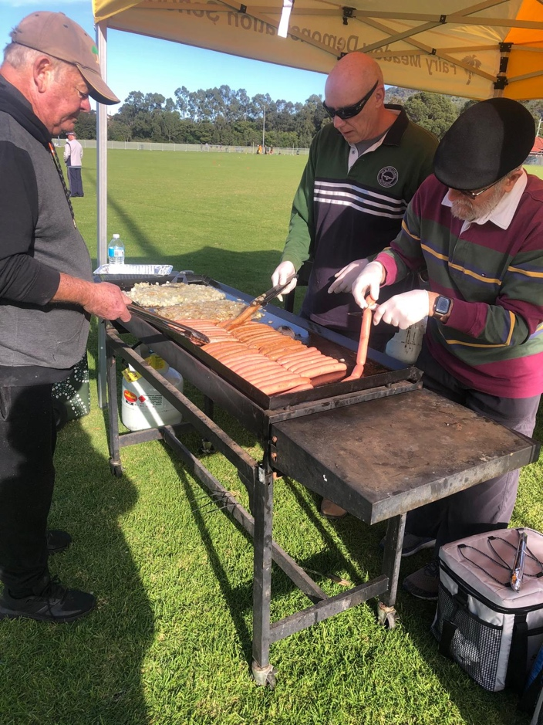 we had a great system going, look at these professionals.

***SHOW AND TELL:***

Masi has been very busy: 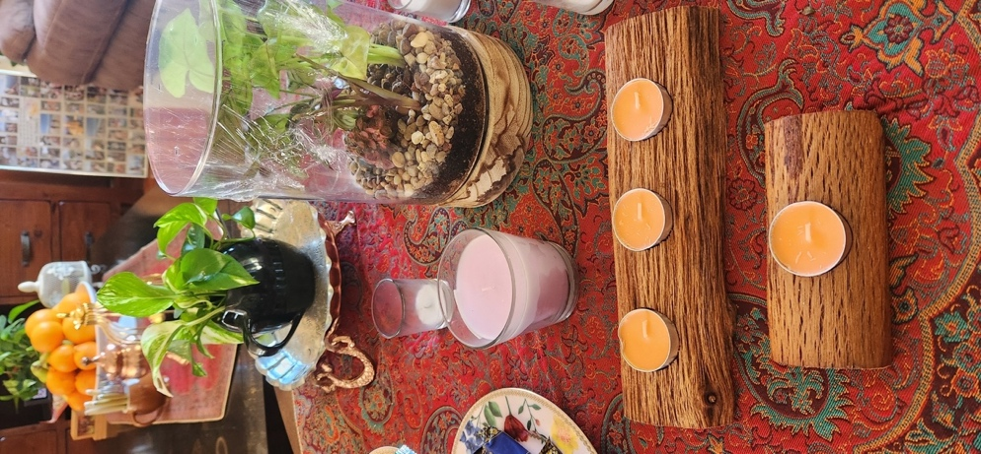 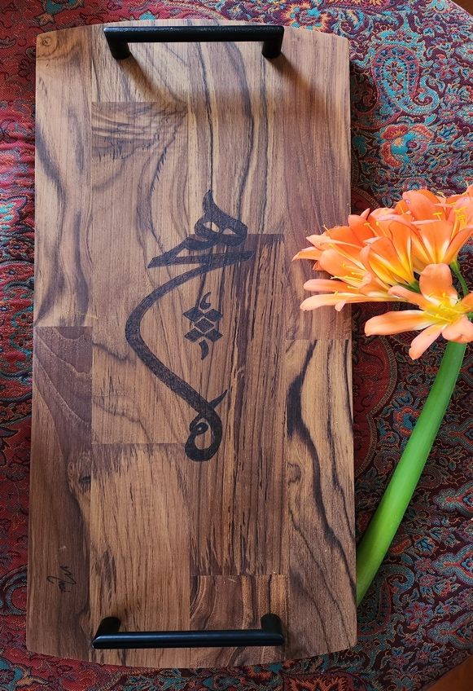

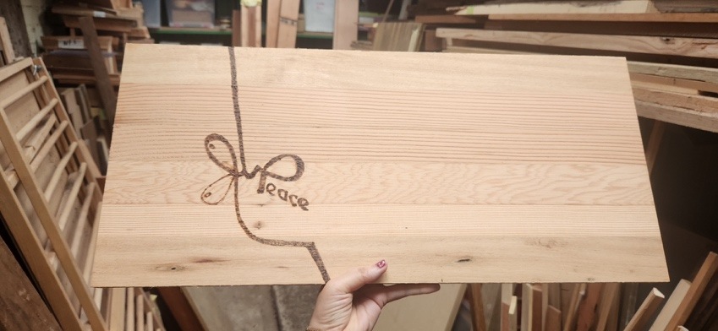

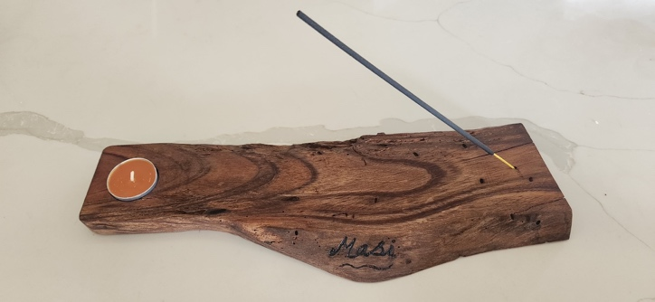 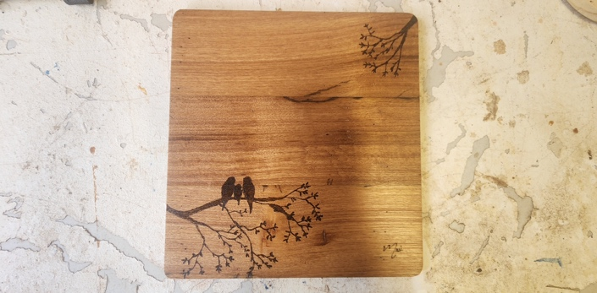

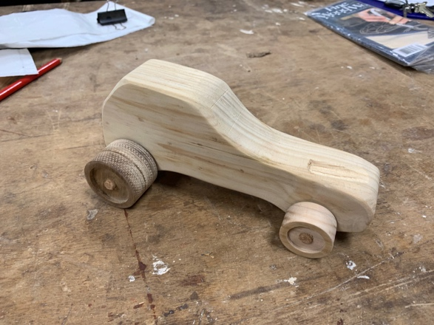 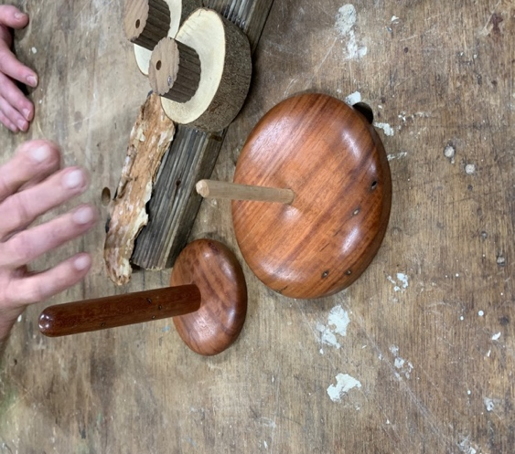

Pat made this dune buggy for his granddaughter, as well as the wool winder (out of red gum).

John Cashman made the fun owl (right).

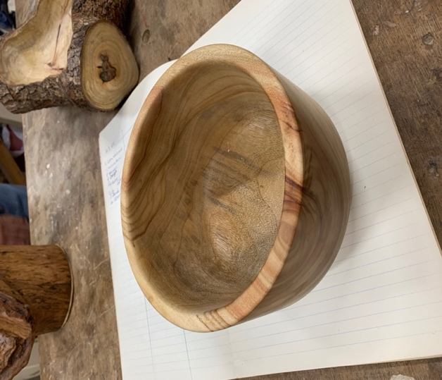 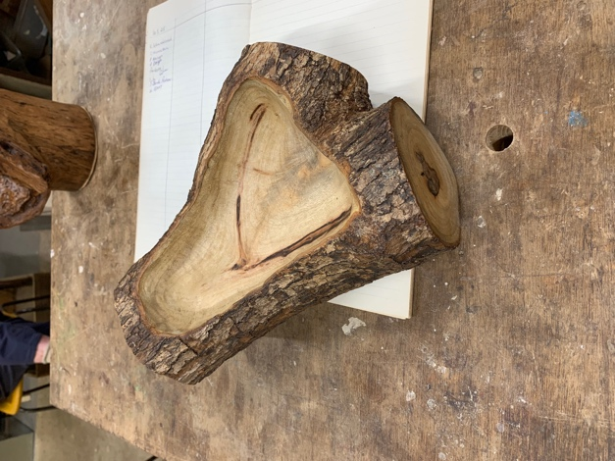

Mark turned this camphor laurel bowl. Rick made a natural edge bowl.

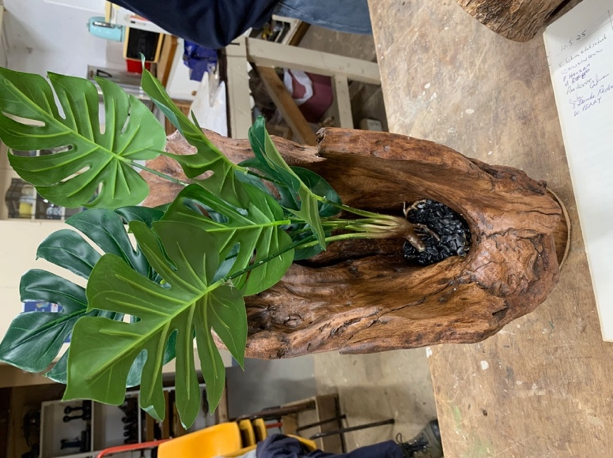 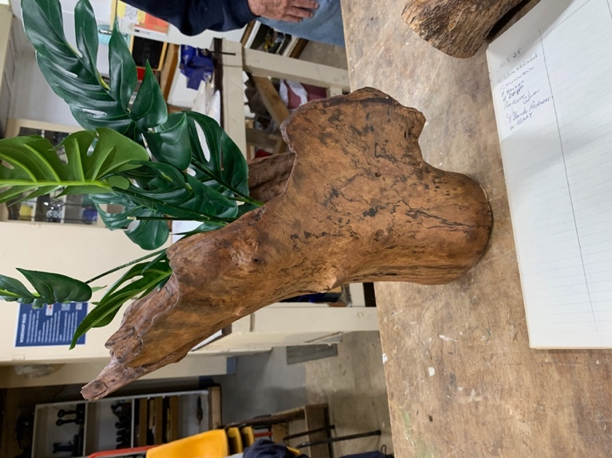

Rick also made this burnt out timber vase out of ‘FOG’ timber. (=Found on Ground).

Pat went to the **Kogarah Woodworking Show** and came back with old planes, Japanese tools; some timber burls and turning blanks (sassafras, native olive, sugi).

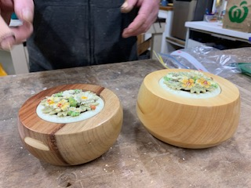

Rick and Dave made these gorgeous potpourri bowls – for Club Sales.

***School Classes***:

This term’s school kids had a great time attending the weekly classes. This is so important for some of these children. For some, it is the only day they attend school…

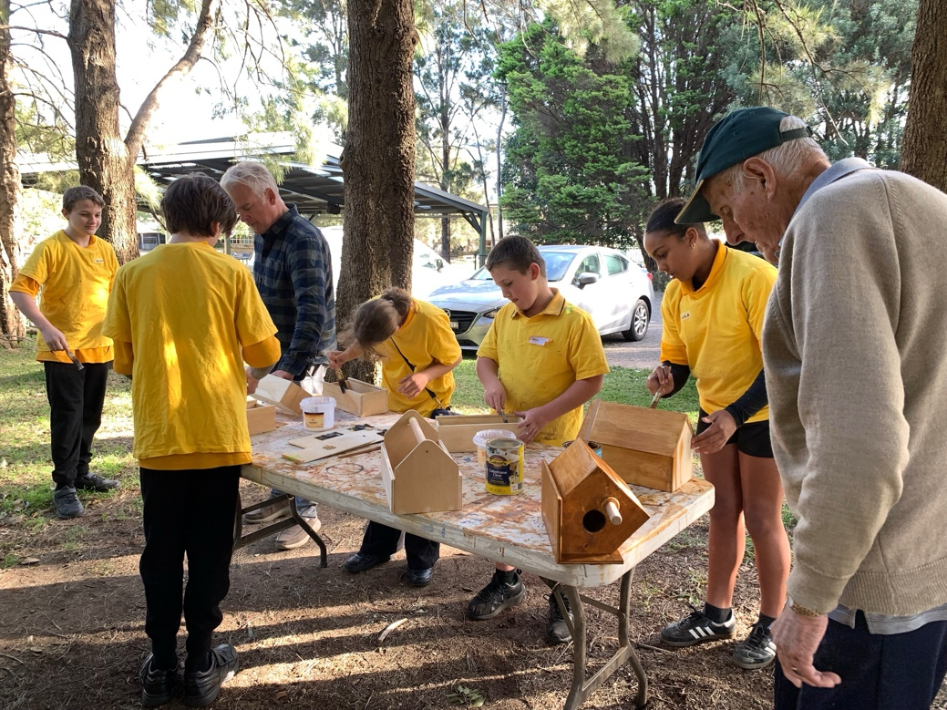

The kids hard at work with varnishing their birdhouses.

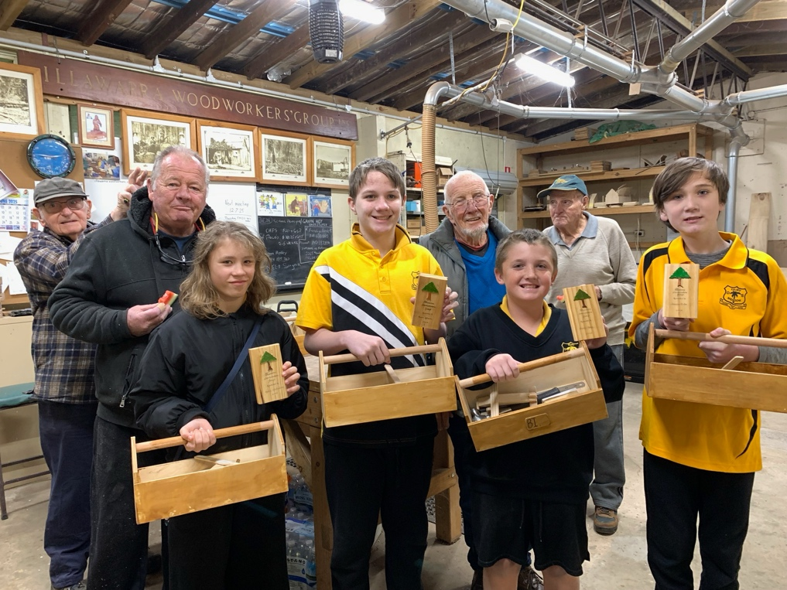

This week they proudly received their trophies, after learning to hammer, measure, fill holes, putty, paint and sand to make a toolbox, a birdhouse, a pencil case and plane. These classes would not be possible without the dedication, preparation and attendance of our club members. Please consider attending, as this needs to continue.

( Here Pete is just like one of the kids!)

**Woodworking groups**

If you are interested in what other Woodworker Groups are doing, Pat kindly supplies me with the links to the Knox and District Woodworkers Club (Vic) NEWSLETTER **Edition** **– June 2025**   **Vol 37.  Edition: (08)**

The **LATEST KDWC edition** of  the "Ingrained" newsletter is now at

**<https://www.knoodies.org.au/current>**

***MEMBER PROFILE: John Cashman***

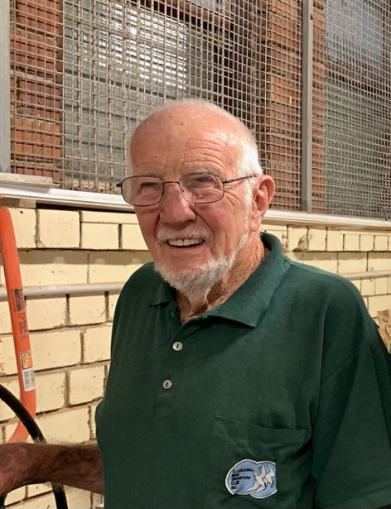

***Question 1: how long have you been doing woodwork?***  22 years.

***Question 2: How long have you been a member of IWG?***  20 (give or take) years

***Question 3: What type of woodwork do you mostly prefer?***  I prefer turning

***Question 4: What item you made are you most proud of?*** I am most proud of the beautiful bowls I turned.

***Question 5: Do you have a shed at home?***  Yes, I do.

***Question 6: Did you ever have an accident while doing woodwork?*** No, I have not had any accidents.

***Question 7: Did you have any disasters at work?***  No.

***Question 8: What do you like about being a member of IWG?*** I like the chance to learn from others.

**NEWS NEWS NEWS NEWS NEWS NEWS NEWS NEWS NEWS NEWS NEWS NEWS NEWS NEWS**

The school has asked us to sign in (and out) on weekdays for our own safety. A sheet with a QR code is now attached to the steel cabinet left of the sink. This is **IMPORANT**, as the school needs to do a head count of everyone on their premises, in case of an emergency. Please comply.

**Time for some fun:**

**1. A carpenter came around the other day…**He made quite the entrance.

**2. Why was king Arthur unhappy with his new table?**The carpenter had cut some corners

**3. Why are carpenters so good at building stairs?**  
They’re always a step ahead!

**4. How do you torture a carpenter?**  
Rip out his nails

**5. What does a carpenter do after a one night stand?**  
The second nightstand

This is your lot for this newsletter.

Please send in anything you think may be useful/fun for our members.

Cheers

Virginie Schmelitschek

***(Editor)***